Swinburne University of Technology

ICT10001 - Problem Solving with ICT  
Semester: September 2021

Deeper details of the project

Baby Hut by G27

Ict15.swin.edu.vn

|  |  |
| --- | --- |
| Nguyen Thanh Dat | 103804881 |
| Nguyen Thanh Long | 103805143 |
| Ton Tri Trung  Tran Tuan Nam | 103808977  103792643 |
|  |  |

**Class**: ICT10001.2

**Lecturer**: Dr. Duc Minh Le

**Tutor:** Ms. Thuy Linh Nguyen

Table of Contents

1. Use of theme and plugins 2

1.1 Theme 2

1.2 Plugins 4

2. Testing results 6

Performance 6

Portability 7

Links 8

Orders placement 8

Security 10

3. Main features and design 11

3.1 Main features 11

Account 11

Social media 12

Orders and payments 12

Reports generation 13

Essential company elements 13

Communication features 14

Products monitor 15

3.2 Design and Layout 15

3.2.1 Design 15

3.2.2 Layout 16

# Use of theme and plugins

## Theme

The theme we chose was Zigcy Lite. Zigcy Lite provides a beautiful design with main tones of colors are red, black, and white. Furthermore, it was rated 5 stars on WordPress and have had 3,000+ active installations.

Here are some **demos** of the theme:

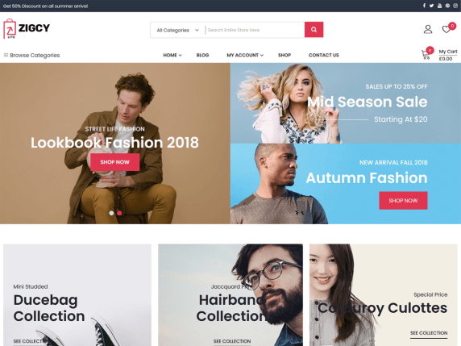

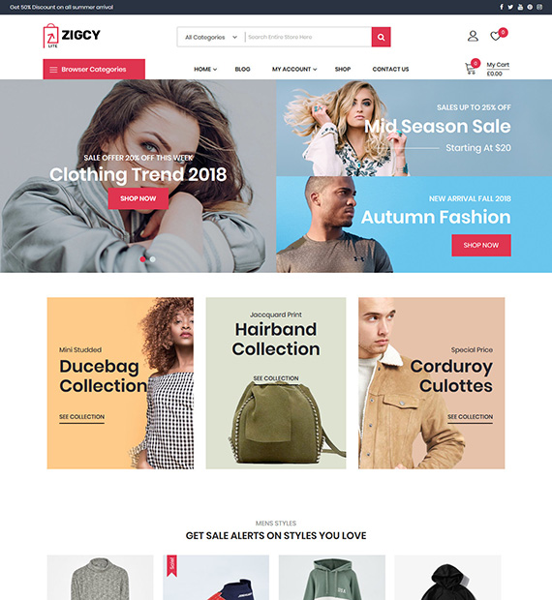

Here is the **Baby Hut version**: 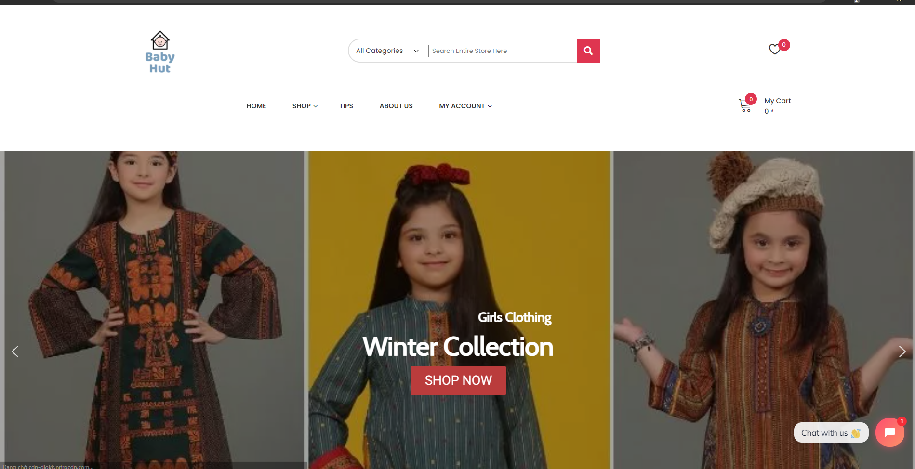

## Plugins

The site has a total of 33 active plugins, here is a brief summary of their name and their function:

|  |  |
| --- | --- |
| **Plugins** | **Function** |
| **All in One SEO** | SEO for WordPress |
| **All-in-One WP Migration** | Import or Export your website |
| **AMP** | Enhance Page Experience for everyone |
| **Classic Editor** | Enables the WordPress classic editor |
| **Classic Widgets** | Enables the classic widgets settings |
| **Elementor** | Allow you to further custom your webpage |
| **Essential Addons for Elementor** | Extend Elementor’s power |
| **Forminator** | Easily create form for registration or contact |
| **Frontend Reset Password** | Allow customers to reset their password |
| **Google Analytics for WordPress by MonsterInsights** | Allow you to view website analysis |
| **Google Listings and Ads** | Allow you to display your ads across Google’s network |
| **GTranslate** | Makes your website multilingual through Google Translate |
| **HivePress** | Multipurpose directory, listing & classified plugins. Crucial for renting function |
| **MailPoet 3** | Create and send newsletters, post notifications and welcome emails from your WordPress |
| **Metorik Helper** | Allow Metorik to connect to your website and give sales analysis |
| **NitroPack** | Allow NitroPack to connect to your website and optimize it |
| **Really Simple SSL** | To install the SSL certificate. However, it is unable to be done due to hosting restriction, but if the restrictions lift off then it will automatically activate. |
| **Return Refund and Exchange for WooCommerce** | Allow customers to refund their orders |
| **Smart Slider 3** | Allow you to create sliders for promotions. |
| **Stock Locations for WooCommerce** | Allow you to easily manage stock between branches of the store. |
| **TaxoPress** | Extended Tag Manager. Terms suggestion, and more |
| **Tidio Chat** | Allow customers to live-chat with you |
| **UpdraftPlus - Backup/Restore** | Allow your website to be backed-up |
| **WooCommerce** | Turn your website into an online store. IMPORTANT! |
| **Woocommerce Customers Order History** | Allow you to view customers’ order history |
| **WooCommerce Easy Booking** | Allow renting products |
| **Wordfence Security** | Extra layer of security |
| **WordPress Importer** | Website importer. Default plugin by WP. |
| **WP Mail SMTP** | Further manage your mail system. |
| **YITH WooCommerce Compare** | Allow you to compare products sales. |
| **YITH WooCommerce Quick View** | Allow customers to have a quick look into the product |
| **YITH WooCommerce Wishlist** | Allow customers to add products to their wish list |

# Testing results

## Performance

The website scored 99/100 for desktop and 74/100 for mobile on GoogleSpeed Insights. These numbers mean the page satisfied the requirement of performance speed.

**Mobile:**

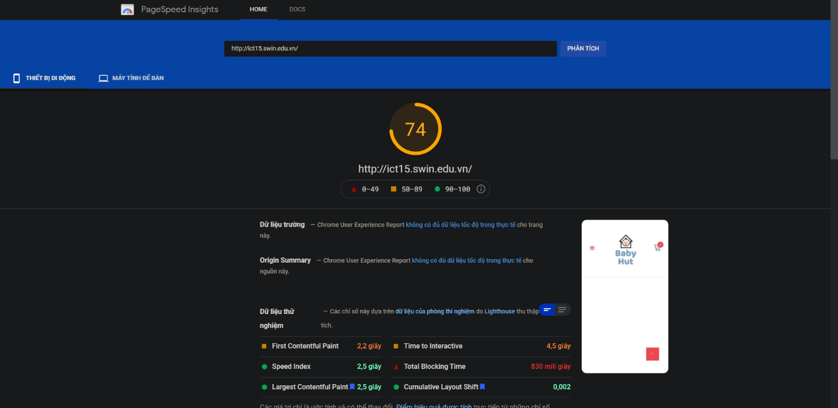

**Desktop:**

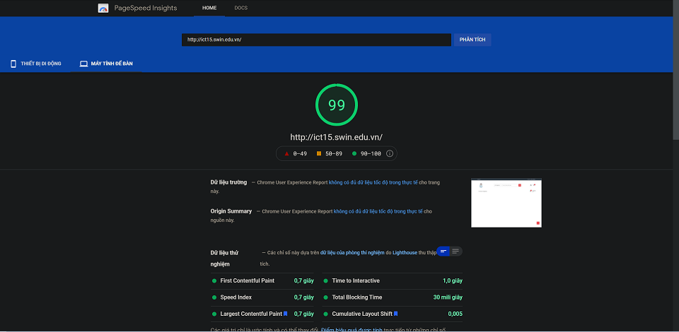

## Portability

The website can be accessed on all types of devices, from mobile to desktop.

**Desktop:** 

**Mobile:**

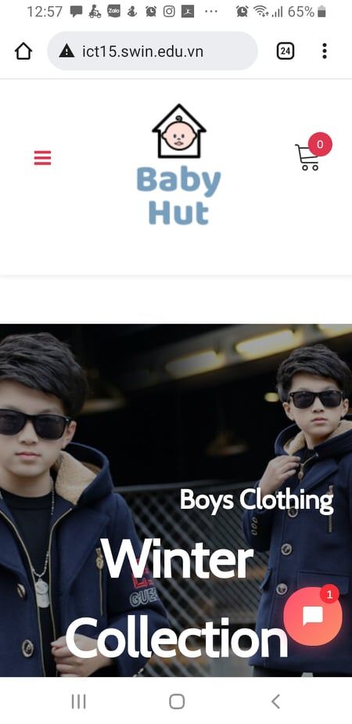

## Links

All the buttons in the site have a destination. There were no dead links (a.k.a 404 error page)

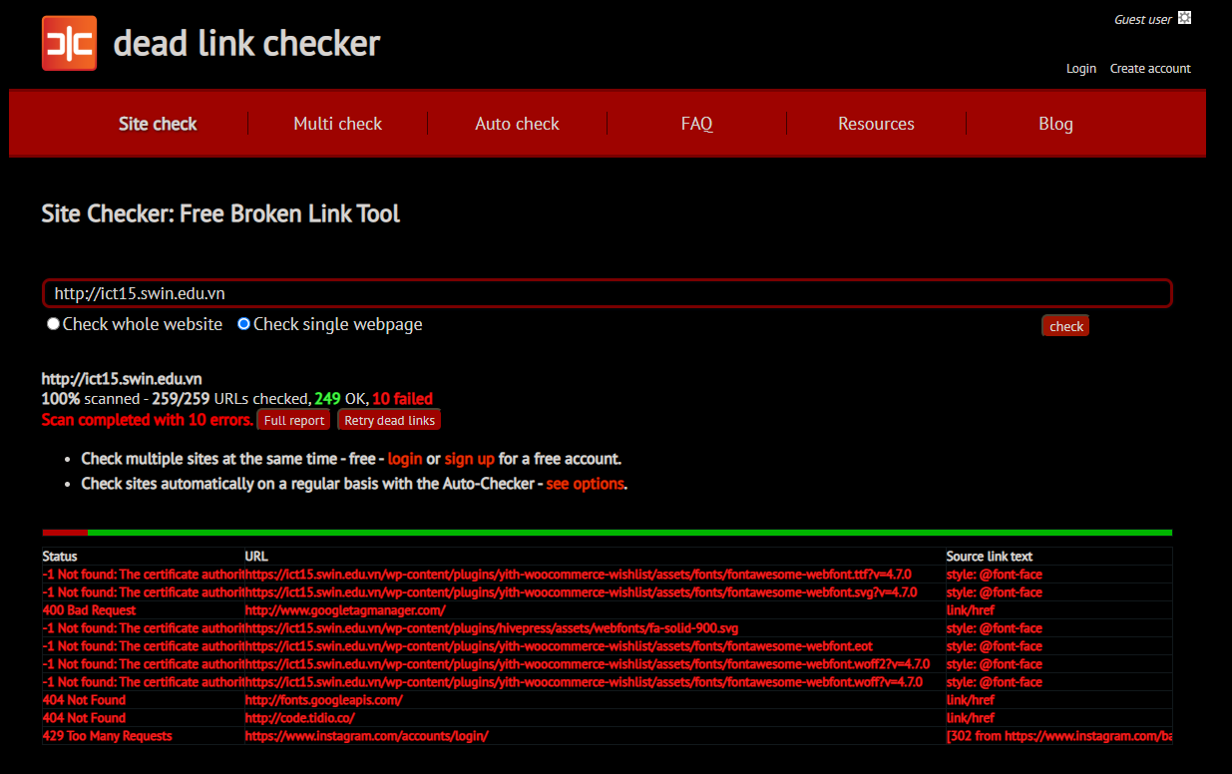

To clarify, all 10 failed links in the picture were either due to Google services for fonts or too many request to a site (Instagram). The site itself has no dead links.

## Orders placement

Both customers and guests can place orders. However, only customers have the ability to rent and refund their orders.

**Placing an order:**

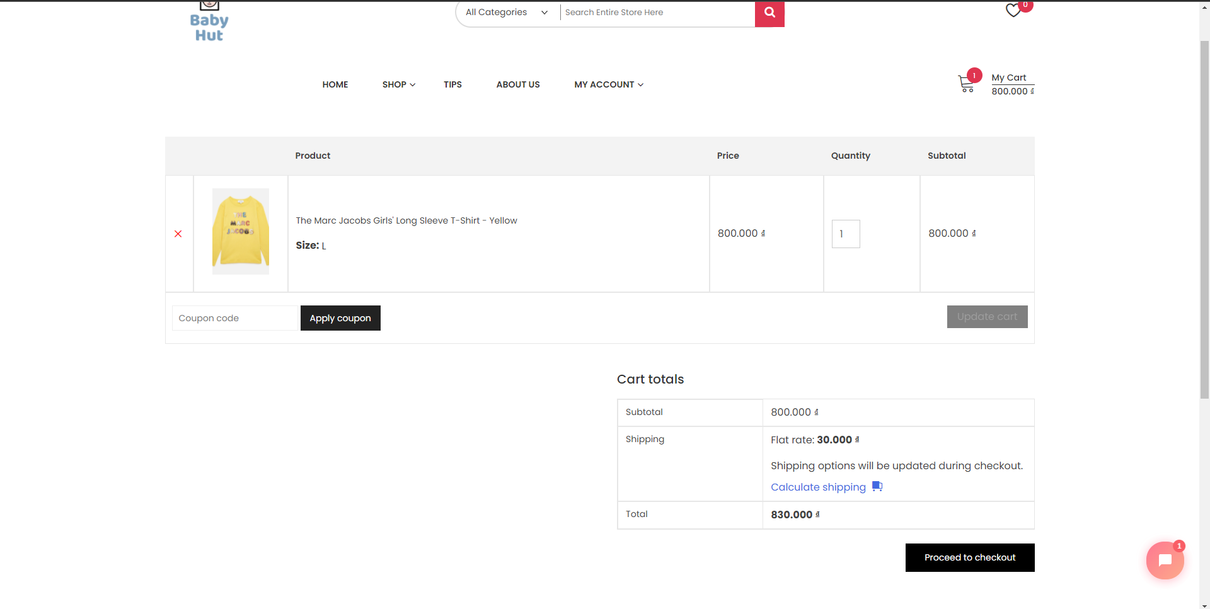

**Checking out:**

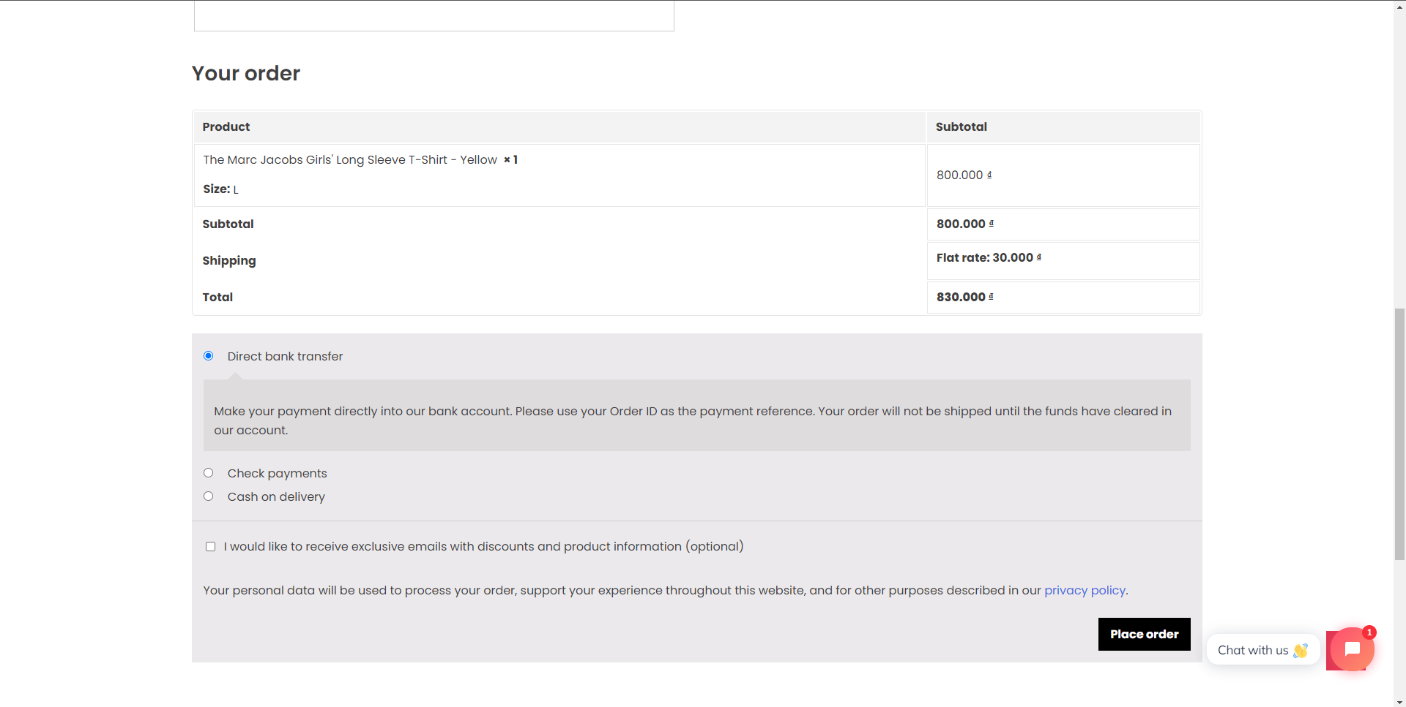

## Security

We were not able to install the SSL certificate due to hosting restrictions. However, we successfully deployed a backup service for the website as well as a security service

**Wordfence security service:**

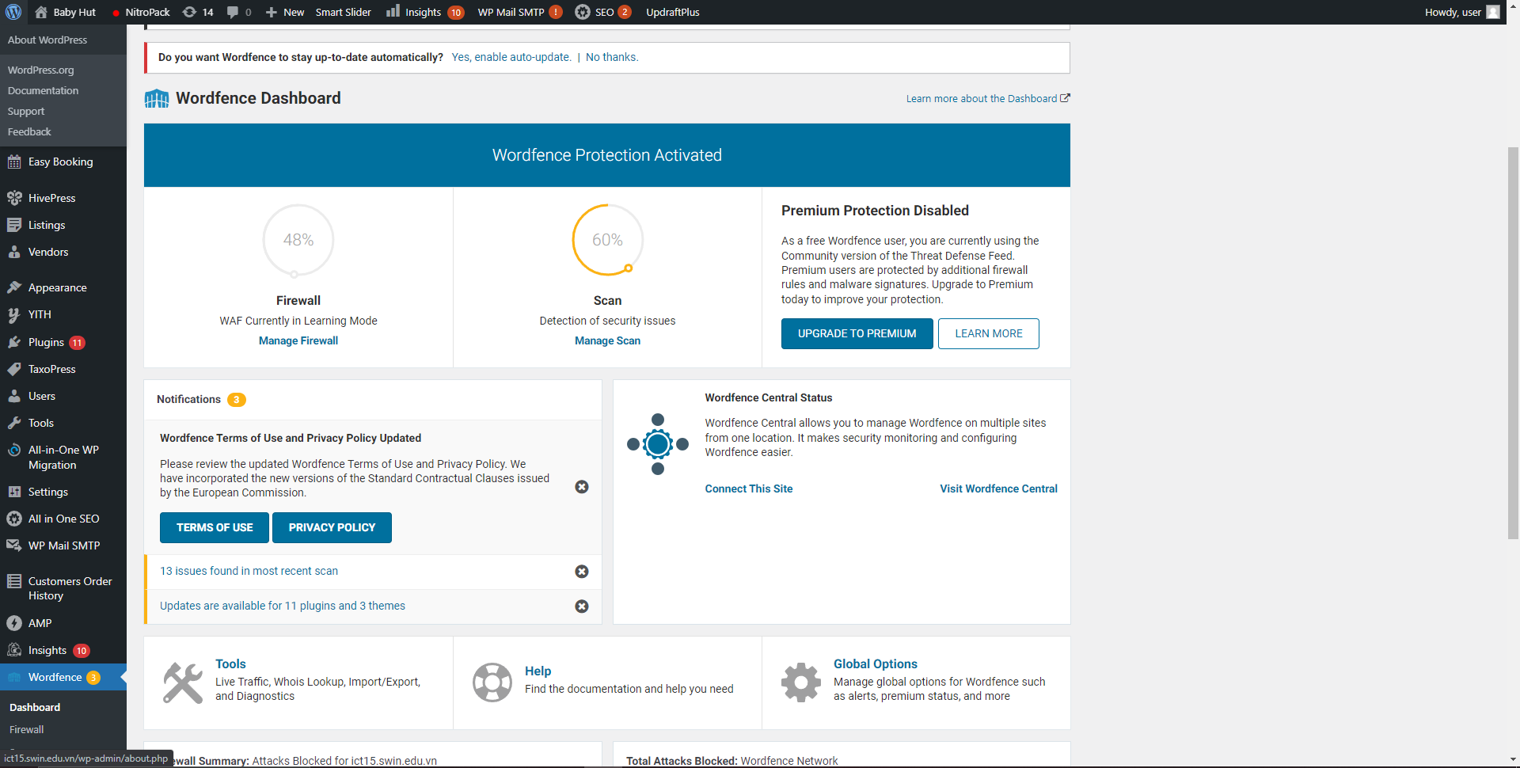

**UpdraftPlus back up service:**

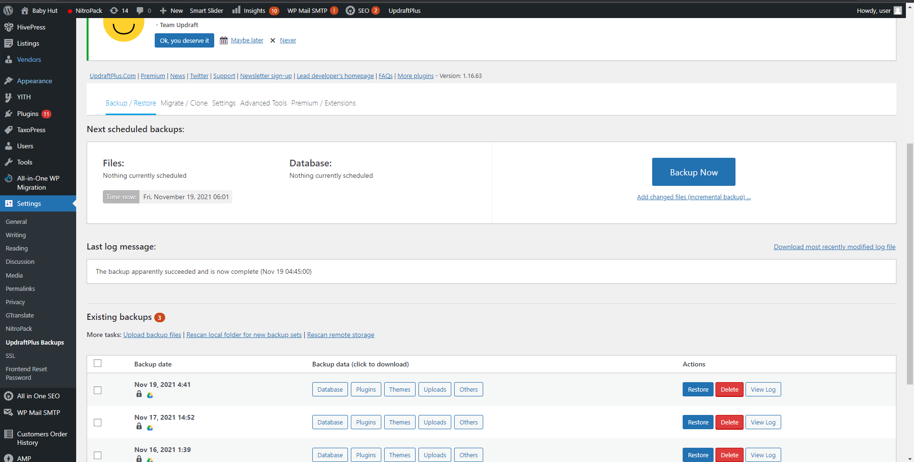

# Main features and design

## 3.1 Main features

### Account

Customers can sign up for membership of Baby Hut. An account allows customers to keep track of their orders, wish list, refund, and change their personal information. Moreover, rental products are only accessible for registered customers.

**Account management:**

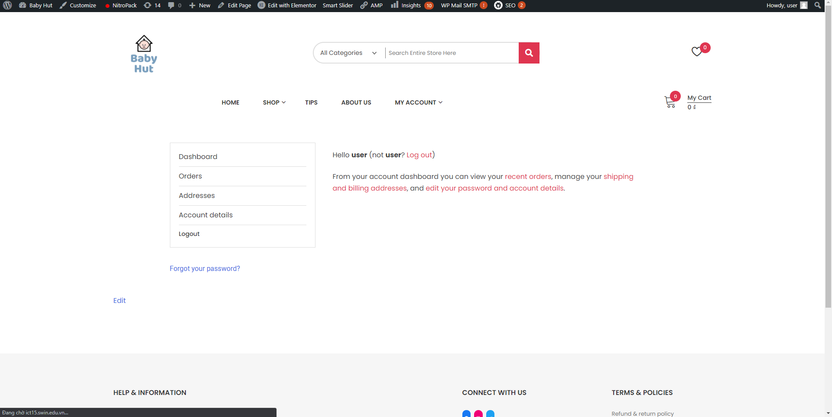

**View orders and refund:**

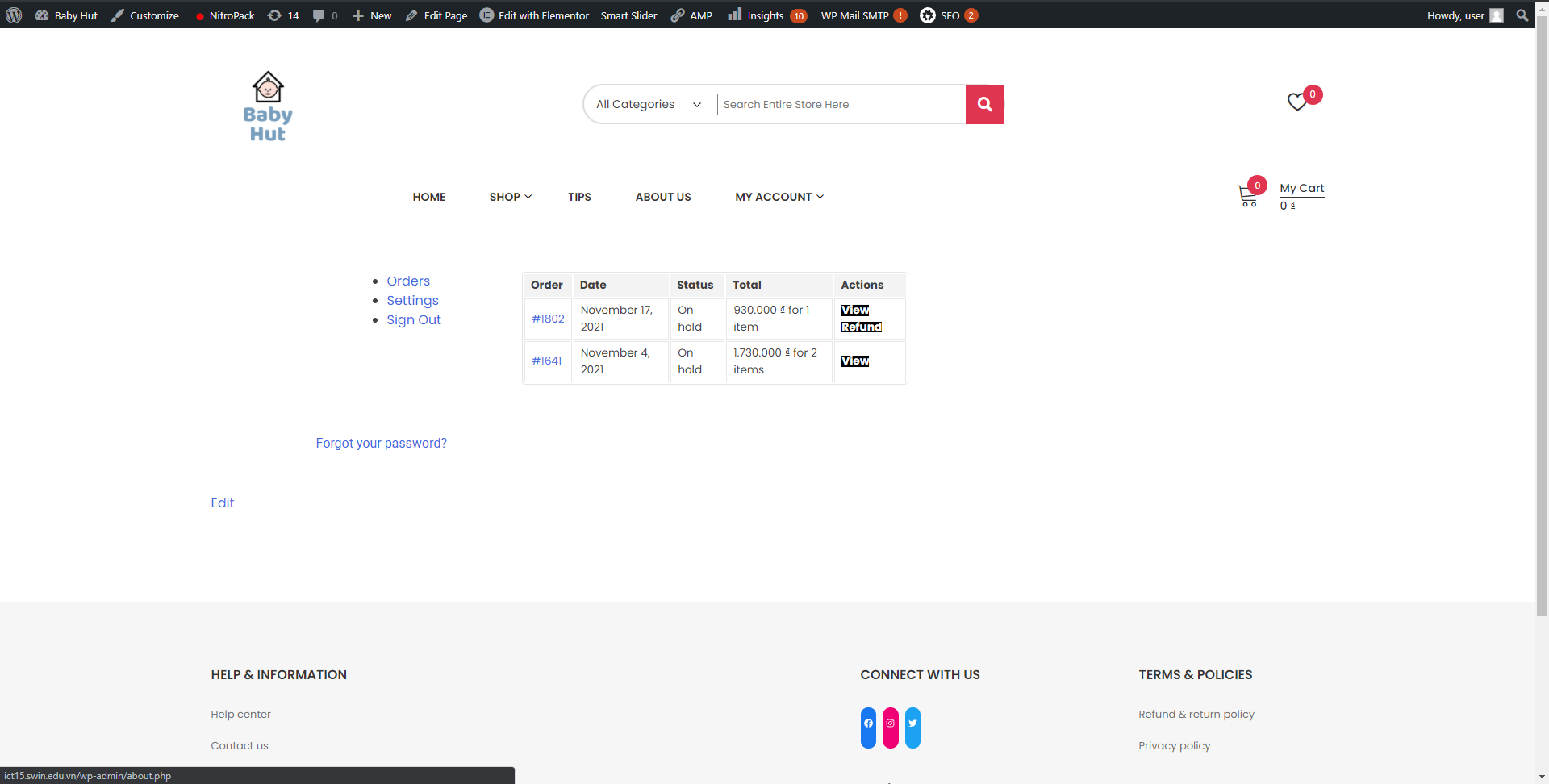

### Social media

Links to social media of Baby Hut have been integrated as icons in the footer of the website. Customers can click on those icons to directly get to the social media page of Baby Hut.

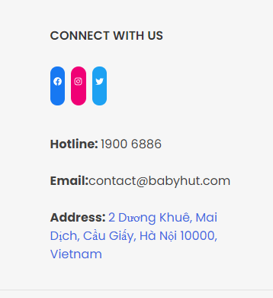

### Orders and payments

Both registered and non-registered can place orders for products. However, only registered customers can rent baby products. They both have a variety of payment options such as COD, bank transfer, or check payment.

**Variety of payment options:**



### **Reports generation**

Most of the required reports by the client are achievable. (Please refer to User-guide provided in the final report for further details.)

### Essential company elements

About us, Meet the team, Contact us are all integrated into the website for customers to get to know about Baby Hut.

**About us page:**

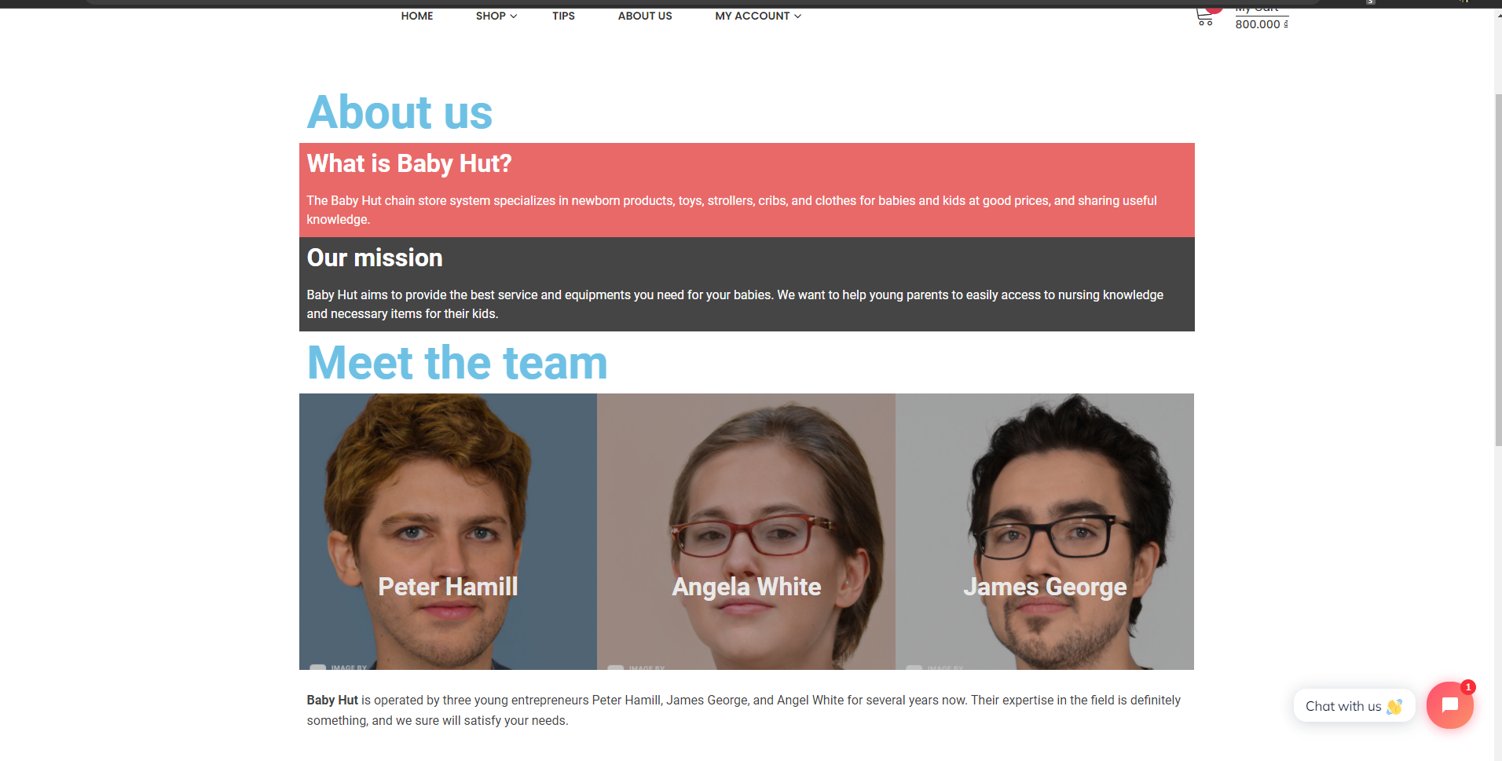

**Contact us:**

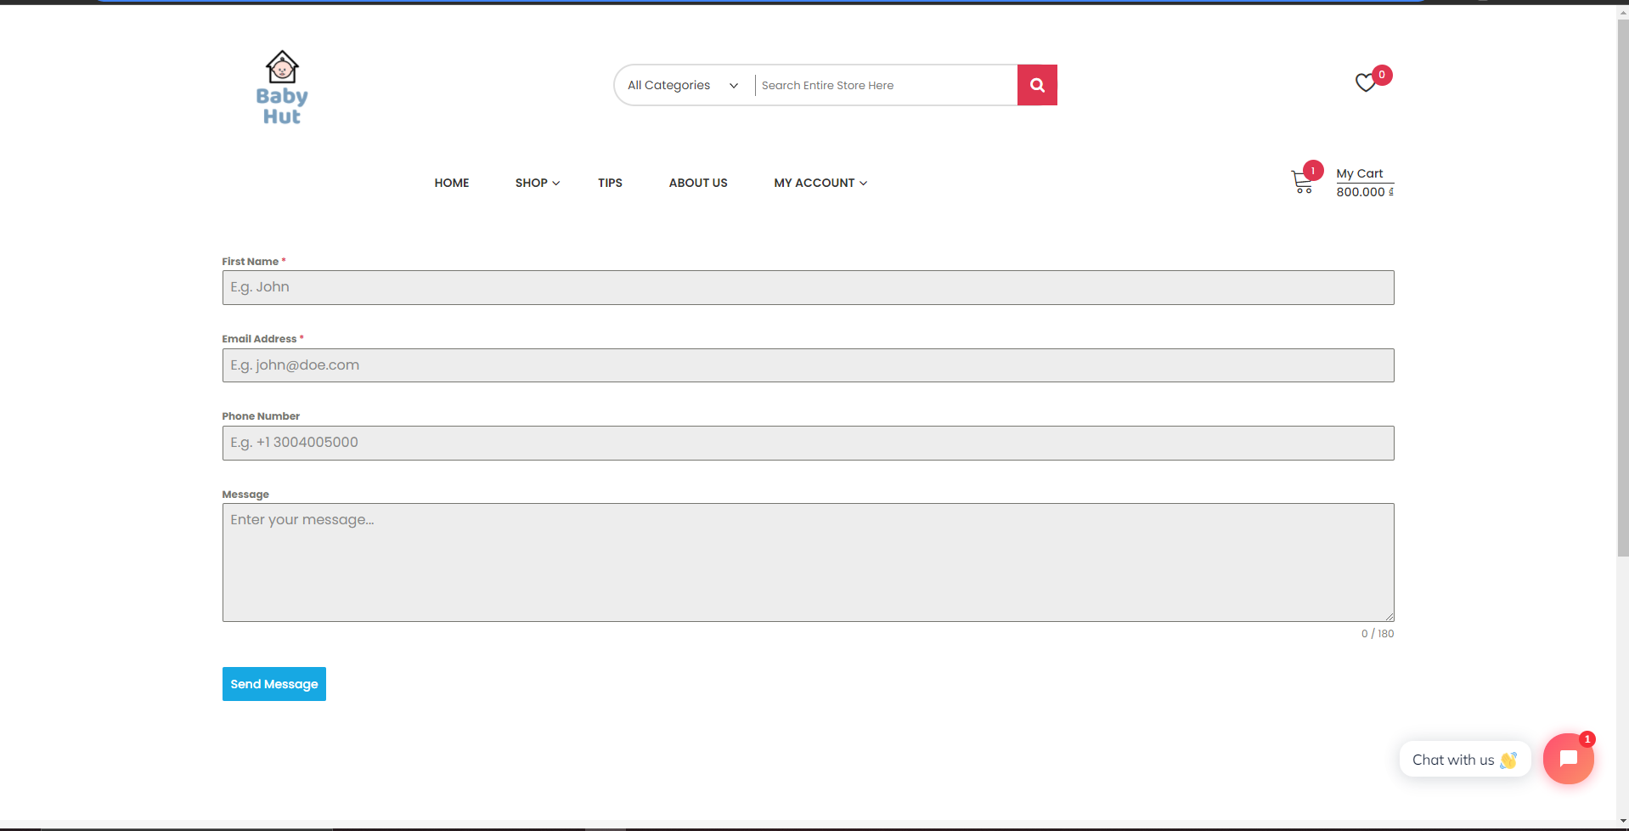

### Communication features

We also added a blog system to allow owners to post tips on baby nursing or size guides. A live-chat function is also integrated into the website to provide real-time support for customers.

**Blog:**

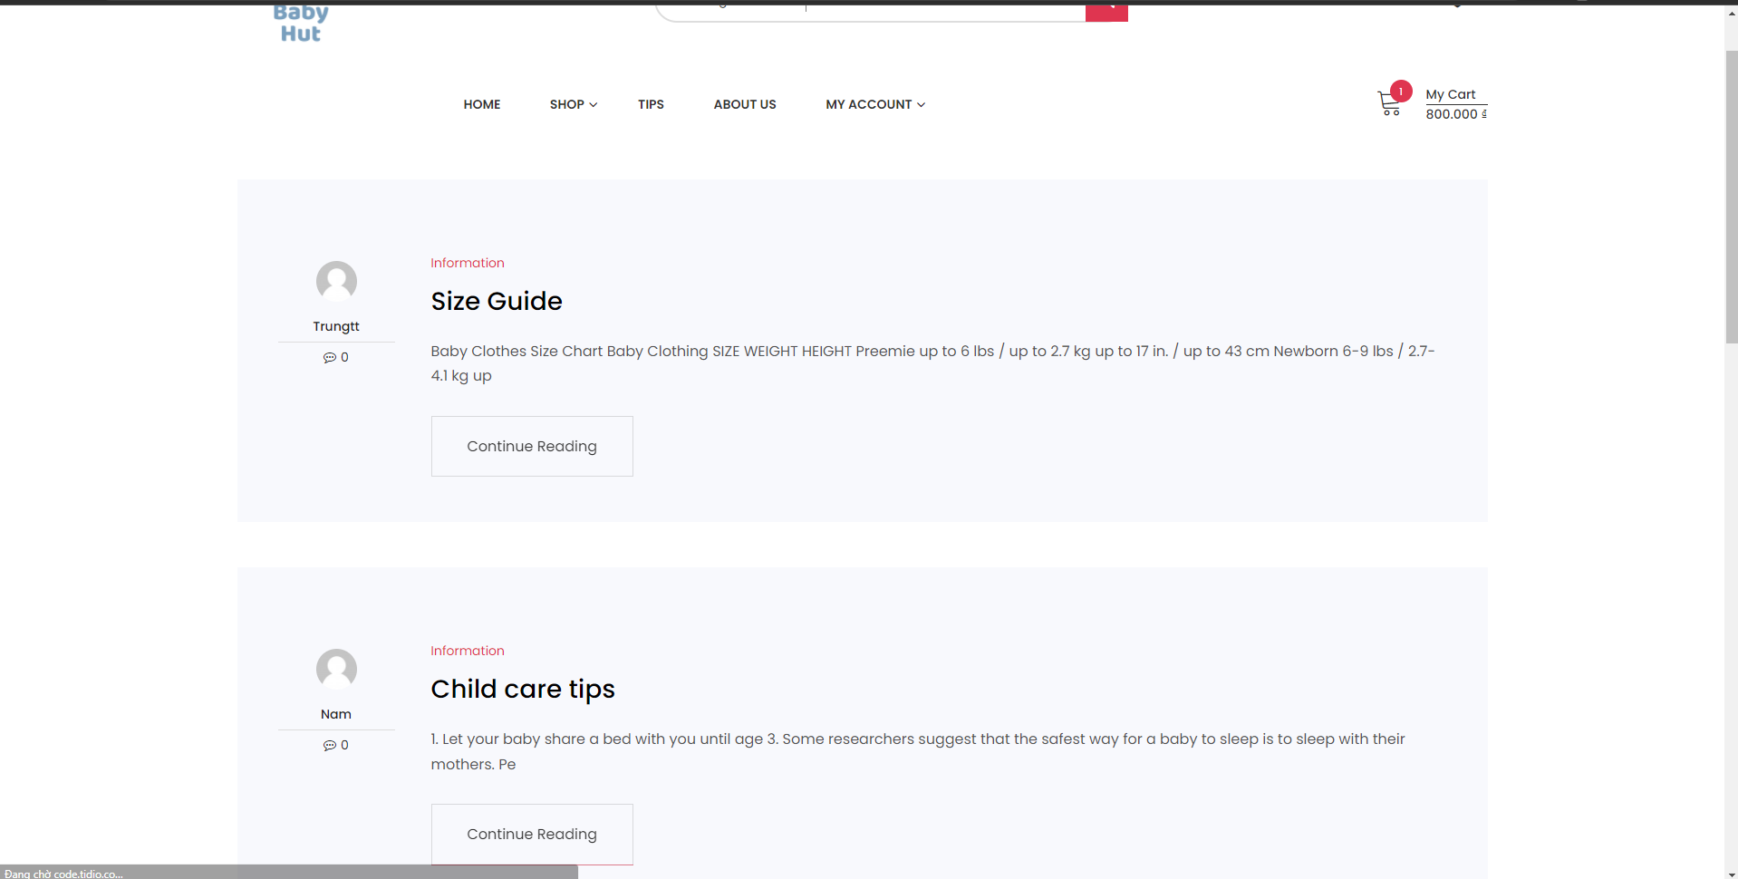

**Live-chat:**

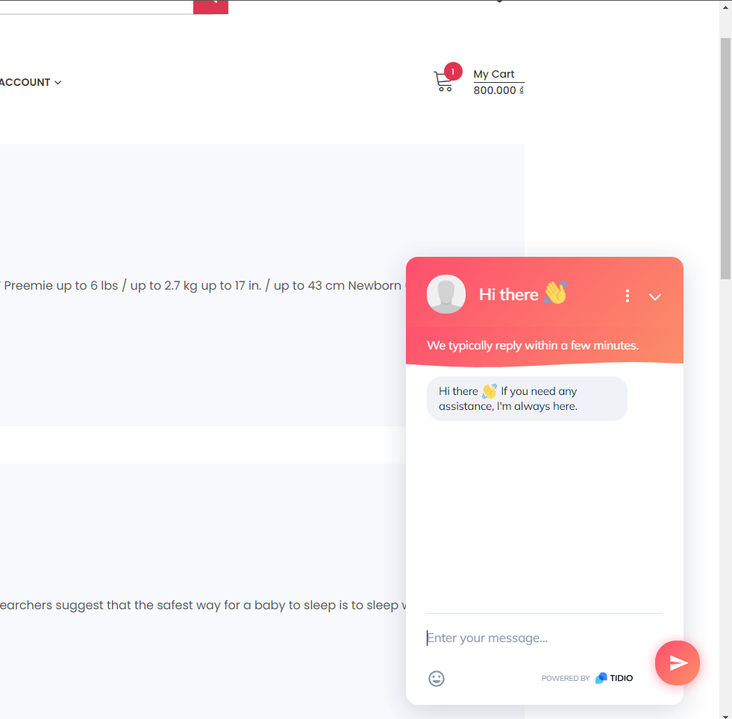

### Products monitor

Owners can easily add, remove, change, and monitor product attributes and stock across branches. (Please refer to User-guide provided in the final report for further details)

## 3.2 Design and Layout

### 3.2.1 Design

About design, we have added:

* **Logo:** A custom Baby Hut website logo.



* **Theme:** Zigcy Lite theme as requested by the client (Simple and lightweight). (Refer to **section 1. Use of theme and plugins for more details**)
* **Portability and compatibility:** Cross-platform compatibility (The website is viewable on any platform). (Please refer to **Section 2. Testing results** for more details)

### 3.2.2 Layout

Here is the website’s hierarchy chart to let you know the flow of pages of the site. 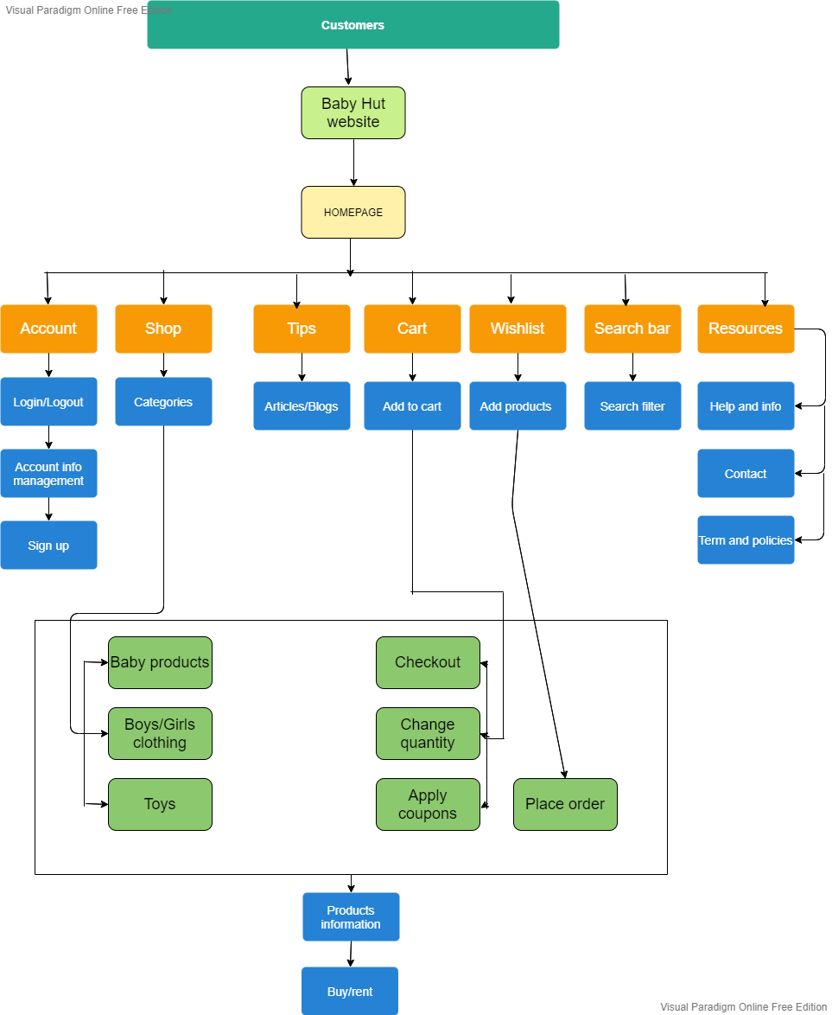

Here is the final layout of the website: